1)Create on Bash script to check if a directory is available or not.

Create a file and edit the file use command **vi file_name**

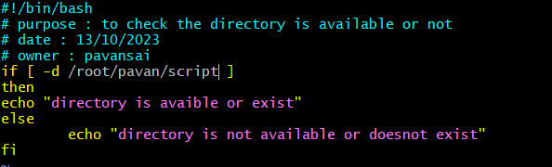

Change the permissions use command **chmod 755 file_name**

And execute the file command is **sh file_name**



If we give incorrect path then it will print directory is not available or doesnot exist

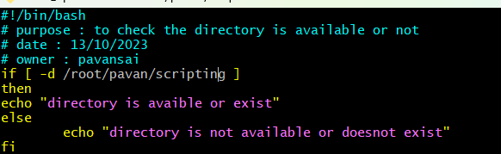

Now iam giving wrong path as above follows, now it shows like as below



2) Create a bash script which will create multiple files.

Create a file and edit the file with command **vi file_name**

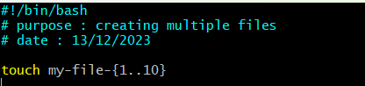

Change permissions and execute the file



3) Create a bash script to take backup of a directory.

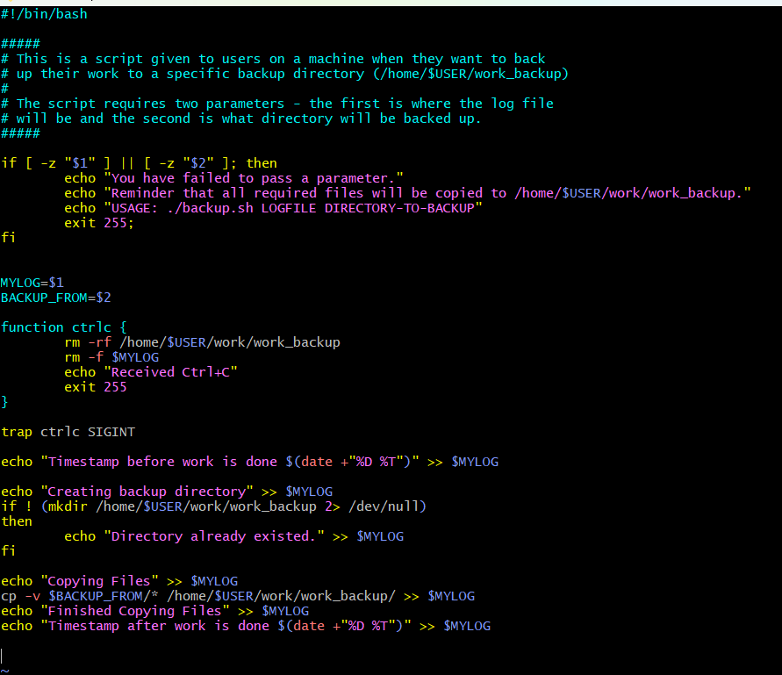

4) Create a bash script to install nginx in ec2 server.

Create and edit a file

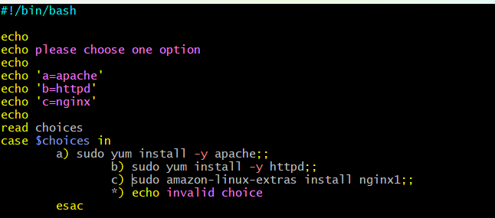

Execute the file

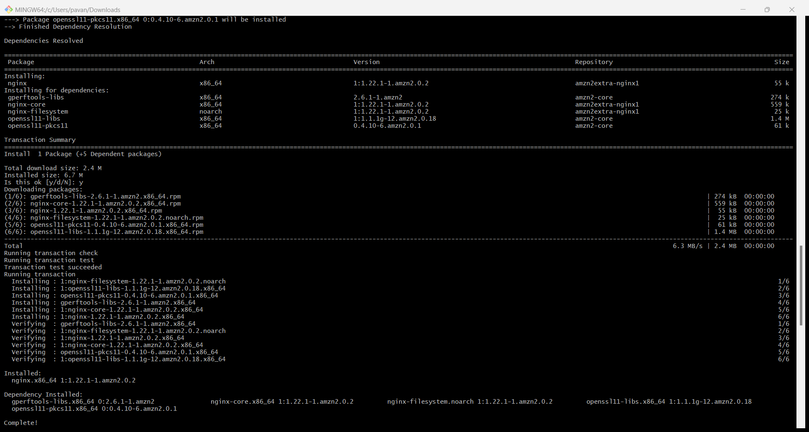

5) Create a bash script to install Apache Tomcat in ec2 server.

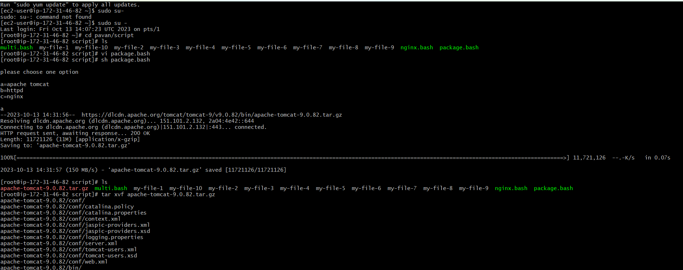

6) Create a bash script to check list if nginx service is running or not,if not running

then script should start the service.

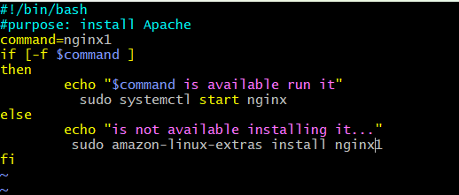

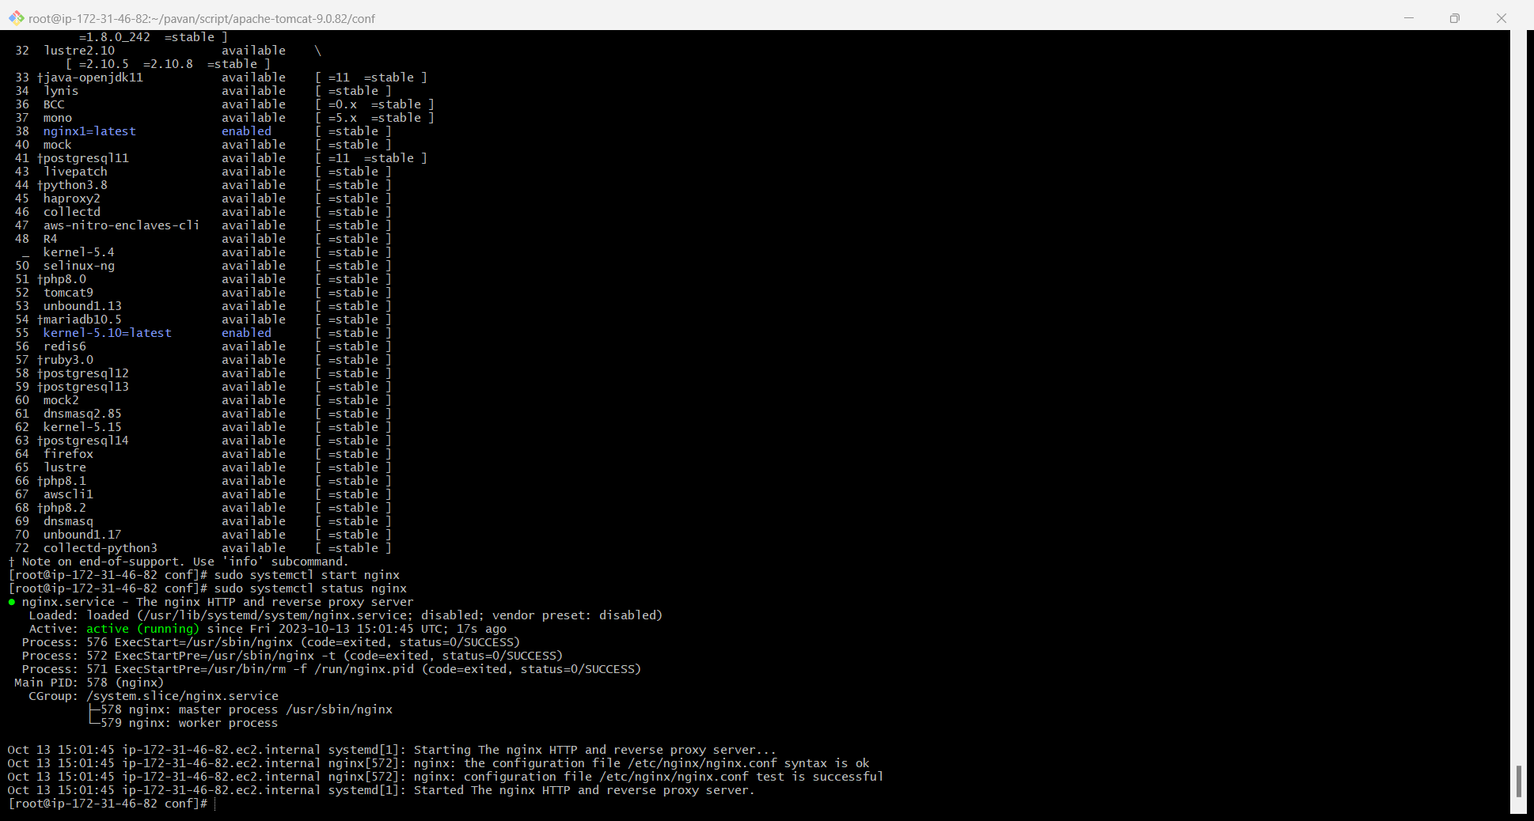

7) Create a bash script for calculator.

Write the code for calculator

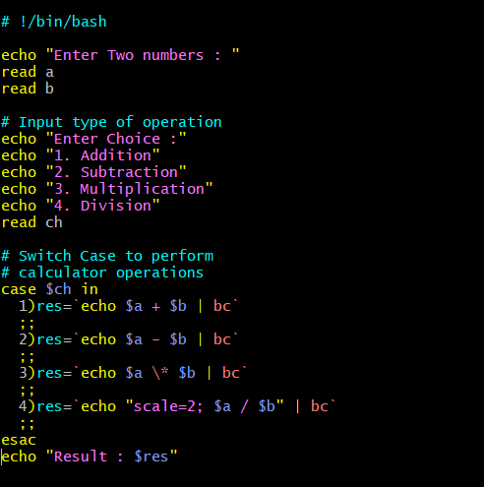

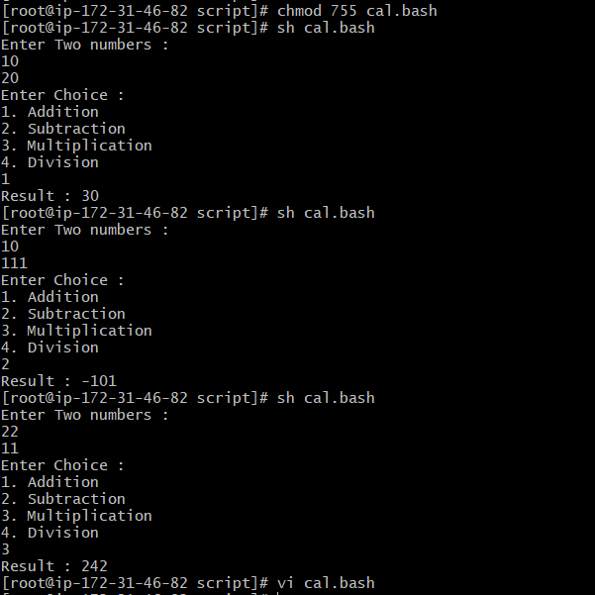

8) Create a bash script to check if directory is avaialble or not,if not then create a directory.

Write the code

